APA Style
Parenthetical Citations and Reference Page Formatting

APA Style is widely used in the social, behavioral, and health sciences. APA style makes it easy to locate important ideas and findings in research, and establishes author credibility through the citation of authoritative research sources.

APA Style consists of:

1) In-text citations:

- In-text citations are brief references in your text that direct readers to the reference page at the end of the paper.

- Use in-text citations whenever you quote or paraphrase someone else’s ideas or words.

- APA uses the author-date method of in-text citation. List the author's last name and year of publication for the source in your text.

There is a correlation between social media and anxiety (Parker, 2019).
Parker (2019) cites a correlation between social media and anxiety.

- If you are quoting a specific passage of text, include a page or paragraph number.

There is a “definite correlation between social media and anxiety.” (Parker, 2019, p. 32)

- View this quick video for a more complete explanation of in-text citation.

2) The Reference Page:

- Lists a complete reference for each source under the title “References.”

- Appears at the end of your paper (after the main body and before any appendices).

- Lists sources alphabetically by author, organization or title if no author is given.

*** Citing an online article? Website? Book?
View this Citation Generator to learn how to cite in every format!***

For further guidance:

Author-Date: Sample Citations
Reference List: Basic Rules
APA Student Sample Paper
APA Style
Documenting Tables and Figures

Referencing visual media such as tables and figures can make your research paper more credible and engaging.
Tables are visual displays composed of columns and rows in which numbers and/or text are presented. Click here for sample tables.
Figures are any visual display other than tables. They include charts, graphs, infographics, maps, photos, artwork, etc. Click here for sample figures.
Tables and figures follow similar set up and formatting in APA.

General Guidelines for Tables and Figures

- Number tables and figures sequentially as you refer to them in the text (Table 1, Figure 3, etc.).

- Figures and tables must be mentioned, or “called out,” in the text before or after the table or figure. Do not refer to them as “The table above,” or “The figure below,” but by their number.

Examples:
Table 1 presents the response of the study’s participants …
Participants evaluated the difference in quality between three products (see Figure 5).

- When reprinting a table or figure exactly from another source, acknowledge the source in an in-text citation and in the reference list according to APA Style.

Example: The infographic in Figure 3 (Smith, 2015, p.83) shows that …

- When including the source in the reference list, follow the format for the source type you took the table from (article, web site, video, etc.).

Example:
Smith, I. (1991). The theory of planned behavior. Organizational Behavior and Human Decision Processes, 50(2), 179–211. https://doi.org/10.1016/0749-5978(91)90020-T

- As well as a citation and reference, when you reproduce a table or figure in your work, you need to acknowledge a source in a note directly below it.

- State if the material is reprinted exactly or adapted - use “From” if reprinted or “Adapted from” if adapted. Follow with source information (title, author, etc.). Include a copyright note for reproduced images as seen below.

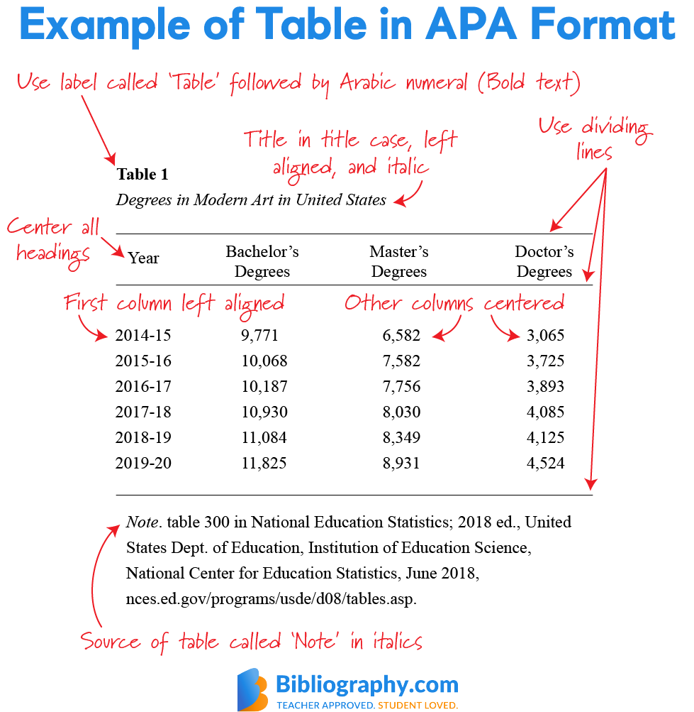

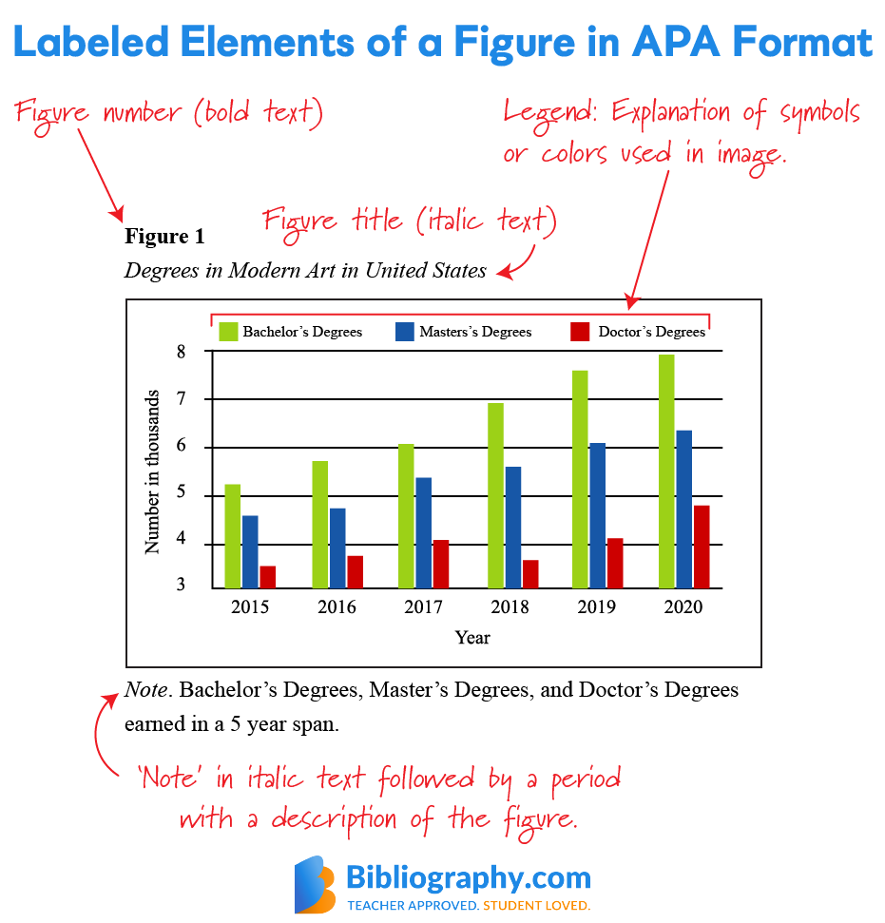
Example of Stock Image in APA Format

Figure 1
Lava the Sled Dog
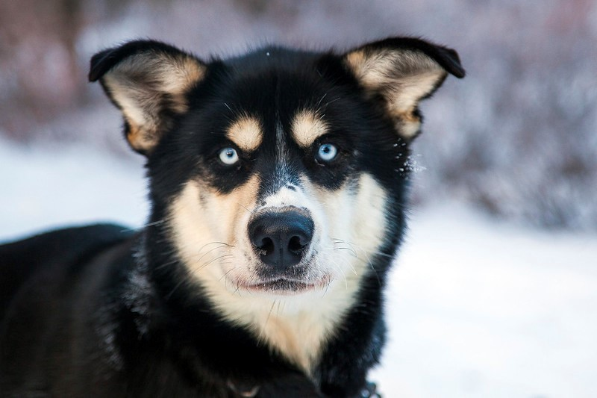
Note. From Lava [Photograph], by Denali National Park and Preserve, 2013, Flickr
(https://www.flickr.com/photos/denalinps/8639280606/). CC BY 2.0.

- For further information about citing tables, click here:
Tables
- For further information about citing figures correctly, click here:
Figures
- For more examples of audiovisual media, click here:
Audiovisual Media
- For further information on how to set up your paper, consult the
APA Style Student Paper Setup Guide.

